1. **Git-HOL**

**Step 1: Setup your machine with Git Configuration**

I have Git already installed and setup in my laptop



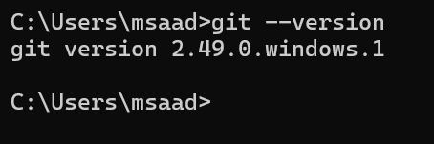

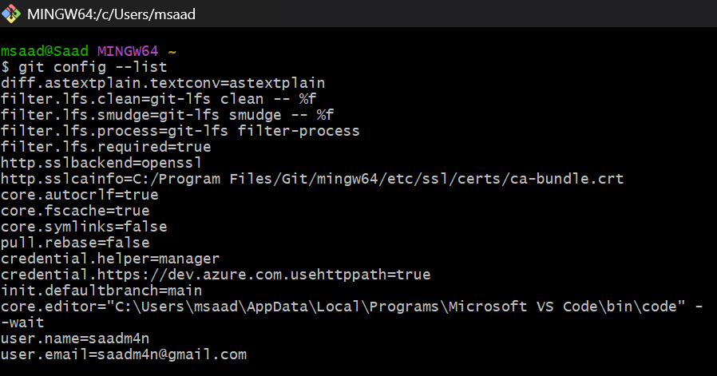

In Command prompt,

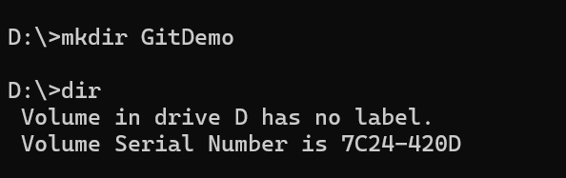

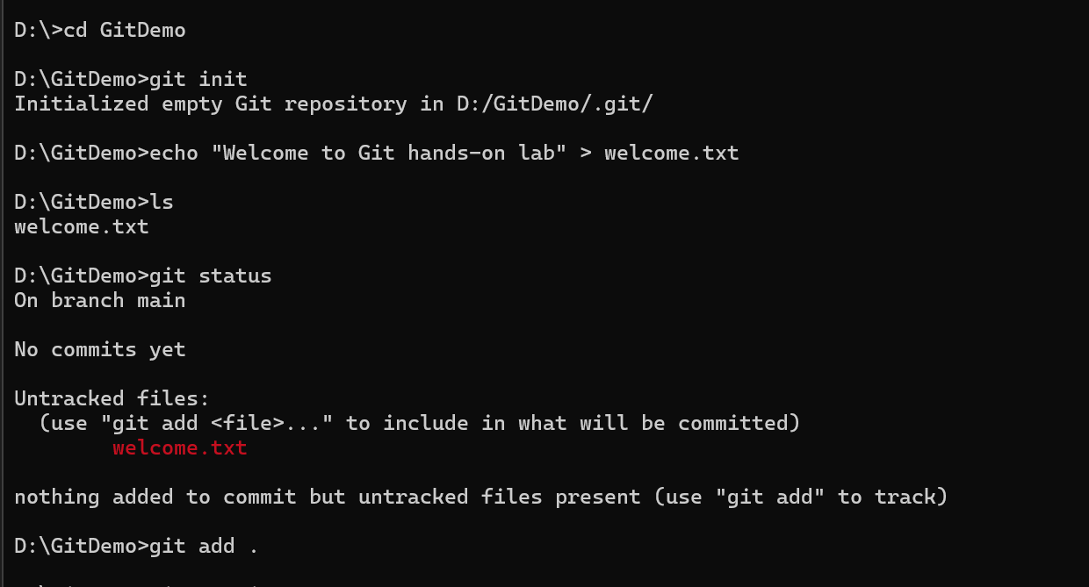

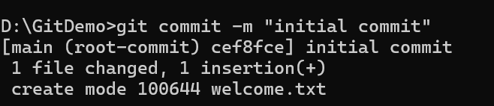

In VSCode

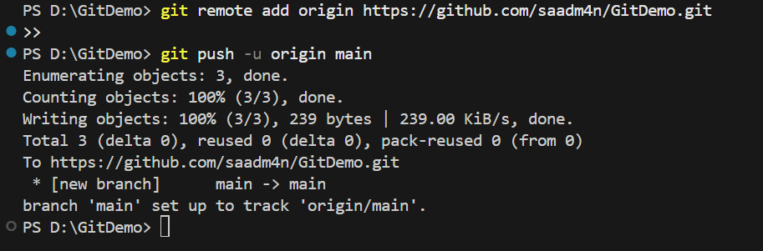

**Output:**

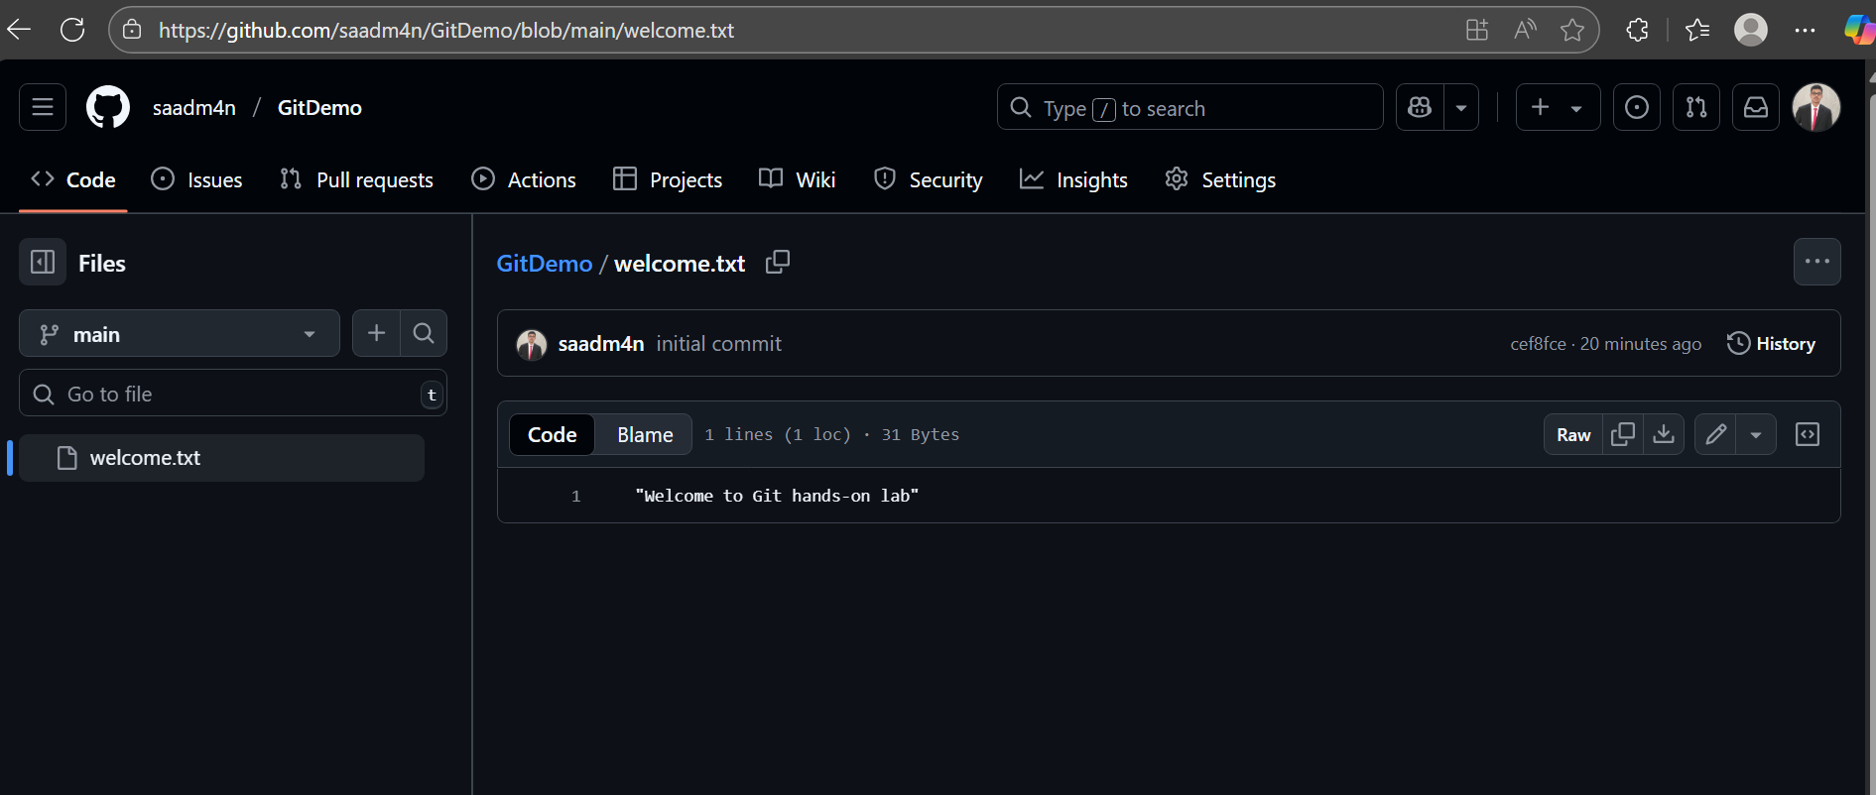

1. **Git-HOL**

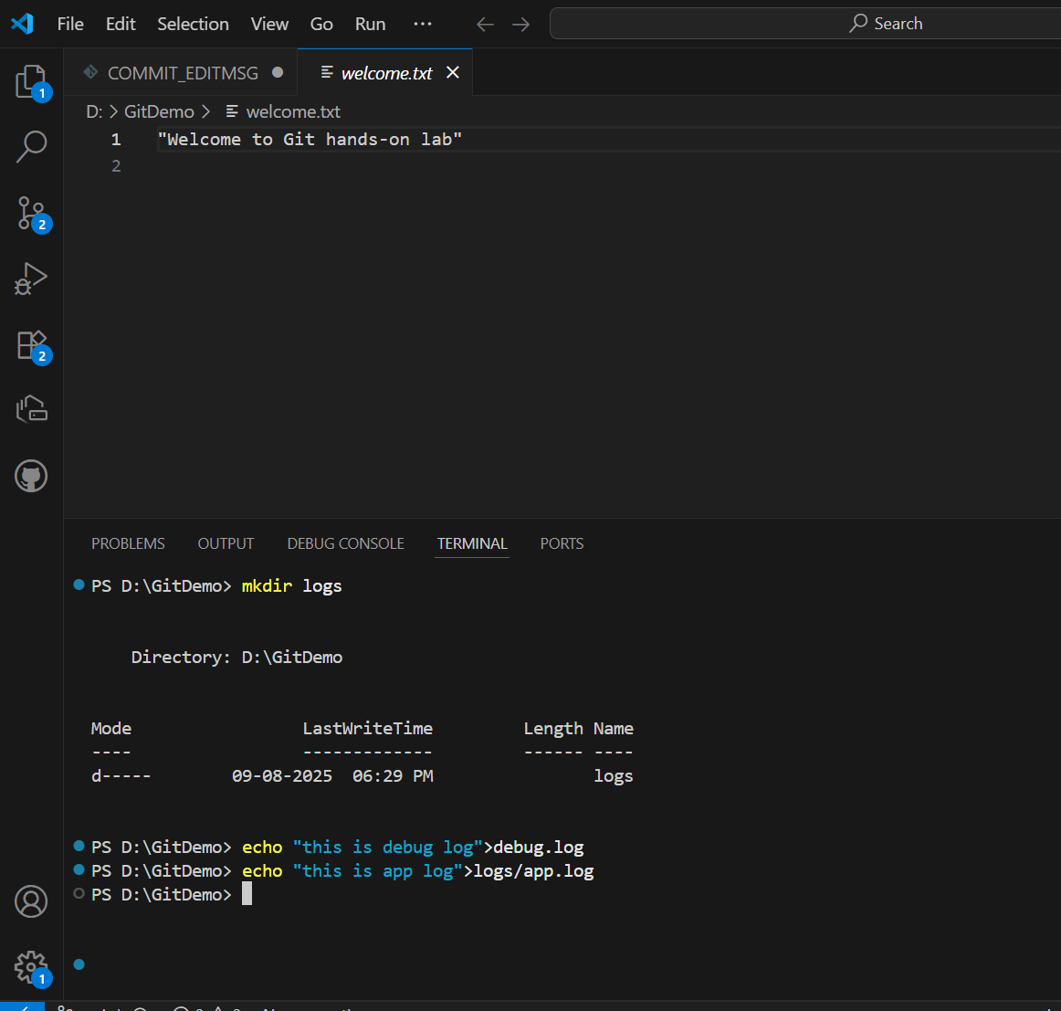

Create a file “.gitignore”

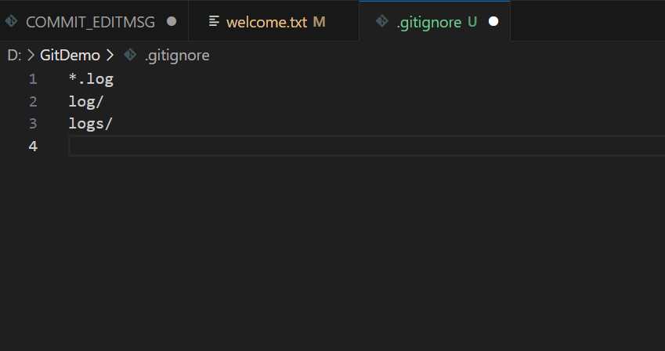

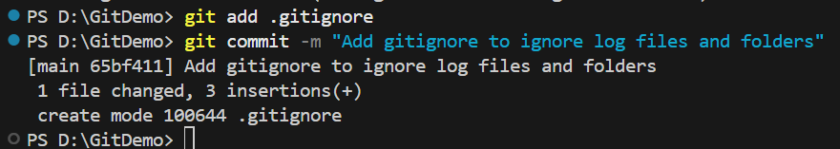

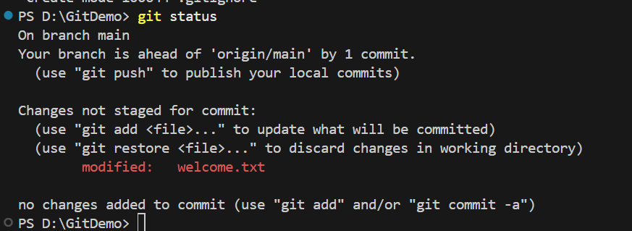

Now, we can see that git is ignoring the log files

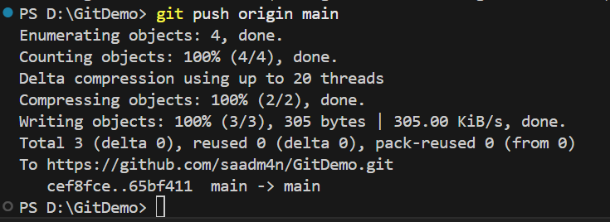

1. **Git-HOL**

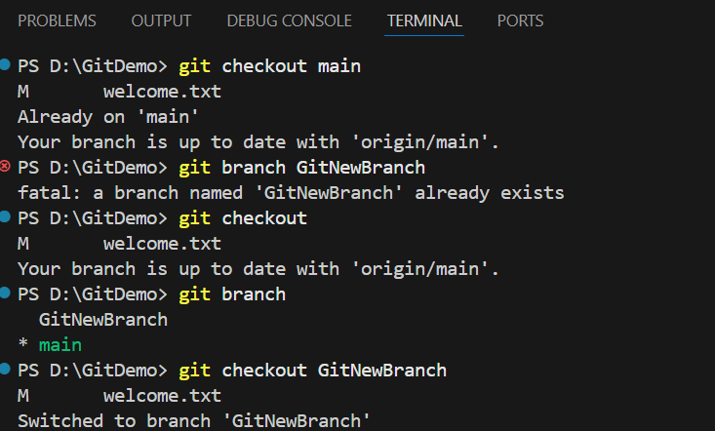

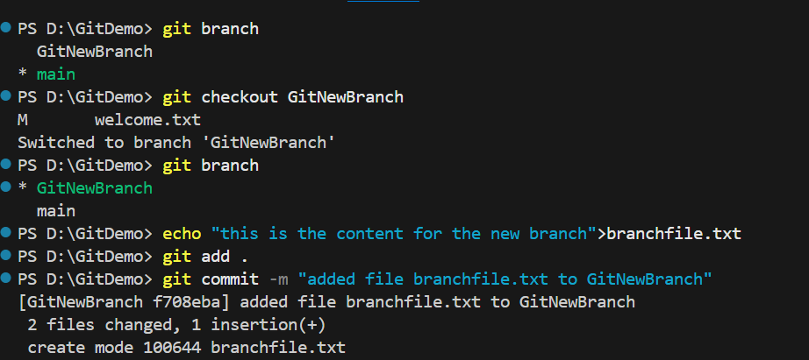

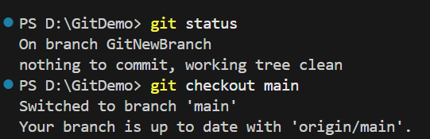

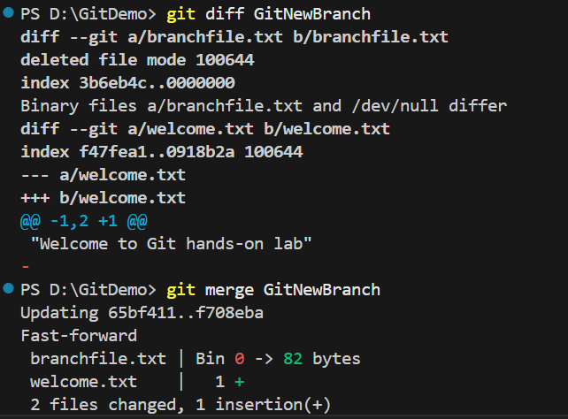

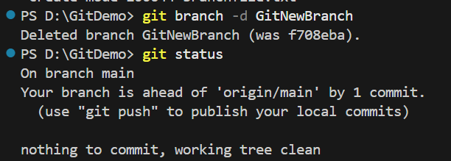

1. **Git-HOL**

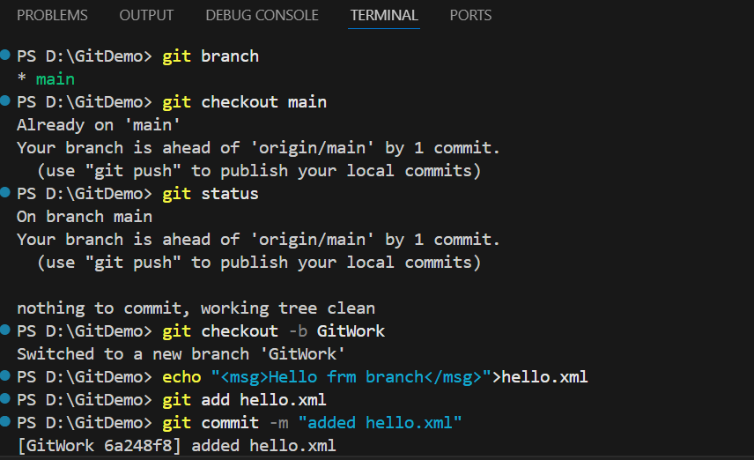

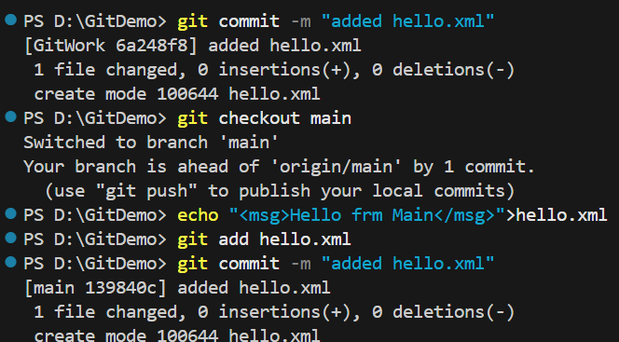

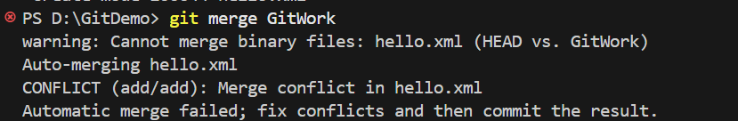

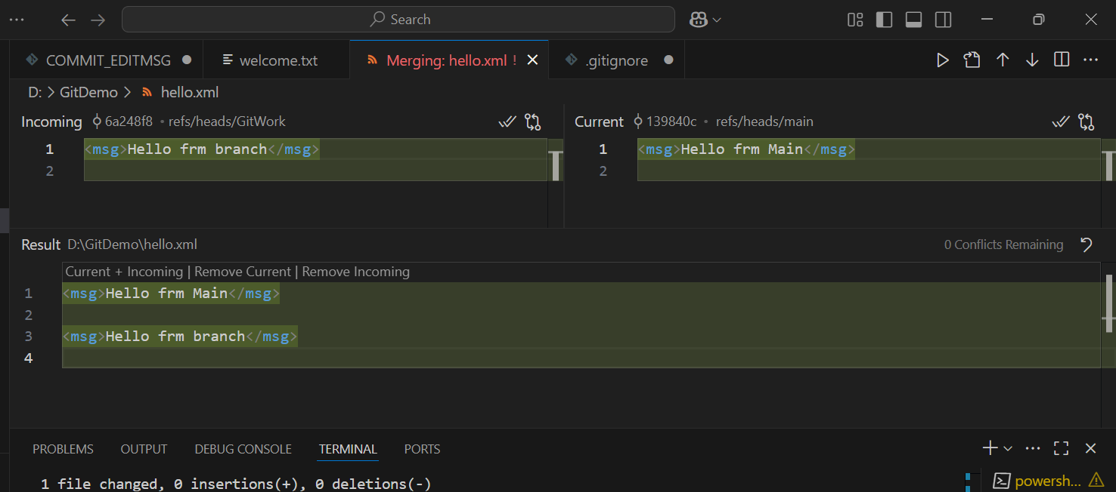

**I have resolved the conflict by choosing accept the incoming change**

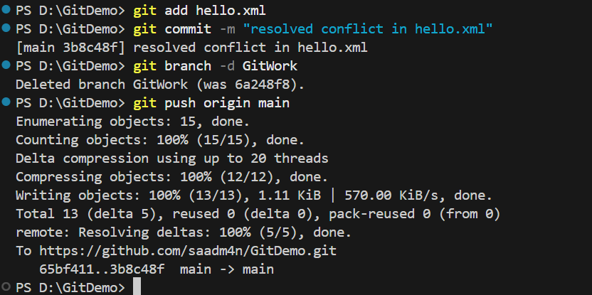

1. **Git-HOL**

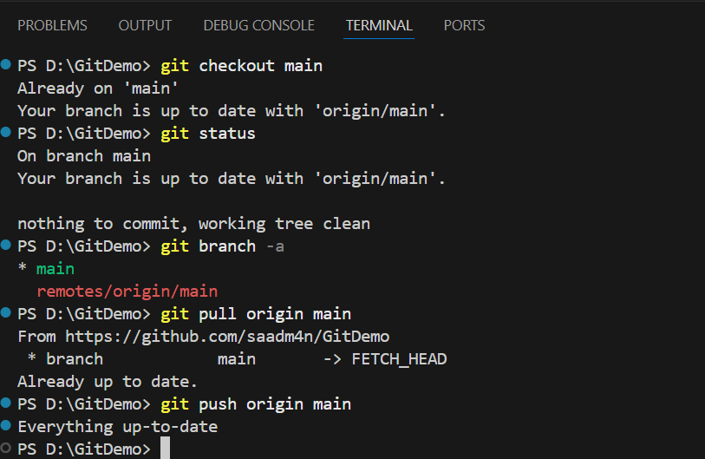

**________________ThankYou________________**